# GYM Management System

## Introduction

The gym management system database consists of 7 main tables that track members, staff, classes, memberships, and bookings.

## ERD

## Main Entities (Description , Attributes and relations)

1. **Member**

* Stores all personal information about gym members
* Attributes: member_id, name, date (birth date), gender
* Related to: Member_Phone, Membership, Member_book_Class

2. **Staff**

* Contains information about gym employees/trainers
* Attributes: staff_id, name, role, gender, phone
* Related to: Class (as trainers)

3. **Class**

* Represents fitness classes offered by the gym
* Attributes: class_id, trainer_id, name, schedule, capacity
* Related to: Staff, Member_book_Class, Class_Sessions

4. **Membership**

* Tracks membership plans for gym members
* Attributes: membership_id, member_id, start_date, end_date, type, status
* Related to: Member

5. **Session (Class_Sessions)**

* Represents specific instances of scheduled classes
* Attributes: start_time, class_id, session_date, end_time
* Related to: Class

### Supporting/Junction Entities:

6. **Member_Phone**

* Stores phone numbers for members (1-to-many relationship)
* Attributes: phone, member_id
* Related to: Member

7. **Member_book_Class**

* Junction table tracking which members booked which classes
* Attributes: member_id, class_id, booking_date
* Related to: Member and Class

## Mapping

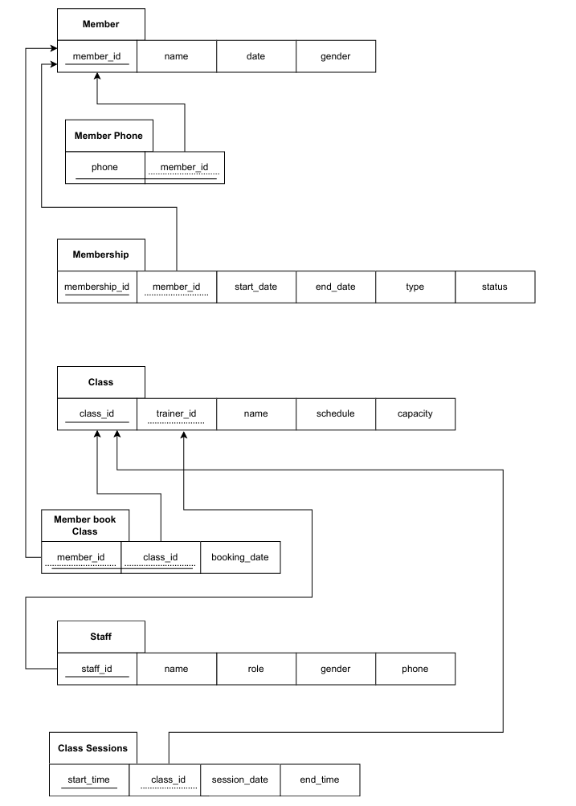

## Tables

### Member

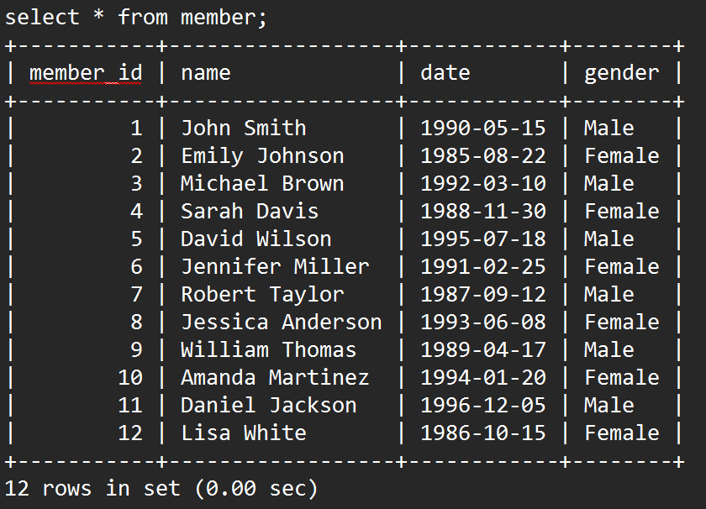

### Member’s Phone

### Staff

### Membership

### Class

### Member book Class

### Class Sessions

## SQL & Some Queries:

1: List all members with active memberships, showing their names and membership types.

2: class that contains the highest capacity

3: Show members with their phone numbers

4: List members by birth date (oldest first)

5: average capacity of all classes

6:How many members does each membership type have?

7: How many classes has each trainer taught?

## 